Research of Economics and Business
p-ISSN/e-ISSN: 2987-1409/2987-1395
Homepage: https://sanscientific.com/journal/index.php/reb
x(x) xx-xx (202x)
https://doi.org/

Research Article (10-14 pages) (Font Calisto MT; 11)

The title should be interesting, informative, and specific according to the content of the article (Max 14 words)-Trebuchet MS 16

First author’s name^{1*}, Second author², Third author³ (Trebuchet MS Size 12-Bold)
¹Department, Faculty, University (Trebuchet MS size 10)
²Department, Faculty, University (size 10)

³Department, Faculty, University (size 10)

Received: 202x; Accepted: 202x

Abstract (Trebuchet MS size 11)-Bold
Abstracts are summaries/extracts of scientific articles (manuscript) consisting of objectives, problem phenomena, data and methods, findings/results, conclusions, and managerial implications/ contributions. Maximum of 200 words. (Font Calisto MT; 10)

Keywords:

JEL Classification: American Economic Association: JEL Guide (aeaweb.org)

How to cite:

Corresponding author: full name (email)

This is an open-access article under the CC-BY-SA international license

1. Introduction (Trebuchet-12)
The introduction explains three essential things in scientific articles: the phenomenon of problems, the rationality of research, and the existing business gap to justify why this research is critical for the economic and business fields. Explanations of general data, the data is increasingly conical to be more specific according to the topic of discussion. The introduction should rely on several vital references (around 5-6 recent related articles) to support the rationality of this research. The final part of the introduction is such as the problem formulation, research gap, the objectives, specific benefits of this study, and novelty (if any). (Calisto MT 11).

2. Literature Review and Hypothesis (Trebuchet-12)
This section discusses studies/reviews of journals, articles, books, and other relevant sources. Hypothesis formulation is presented in this section in the form of in-depth elaboration for the hypothesis argument used. The hypothesis developed must be based on standard theory and the results of previous research. It is recommended that each hypothesis be supported by at least four significant references that you use. (Calisto MT-11)

3. Data and Method (Trebuchet-12)
This section explains the data (population and sample) and the method of measuring research variables (variables description) so that they can easily replicate. In the method section, generally, some models will be used to analyze the data obtained. For example, the optimal cash flow prediction model uses the optimal cash model from Opler et al. (2019):

Cash_{it} = α₀ + β₁ MTB_{it} + β₂ Sales Growth_{it} + β₃ Size_{it} + β₄ NWC_{it} + β₅ CapExp_{it} + β₆ Lev_{it} + β₇ Div_{it} + β₈ Age_{it} + β₉ Industri_{it} + ε_{it}

Where: Cash = cash & cash equivalent/total assets; MTB = the market value of equity/total assets
Sales Growth = salest0 - salest-1 / salest0, size is the natural log of total assets; NWC = the net working capital/total assets; Cap Exp=capital expenditure/total assets; Leverage = total debt/total assets; Dividend = a dummy 1 for those who pay dividends; Dummy 0 = for those who do not pay dividends; Age = the natural log of company age; Industry = a dummy variable

4. Results (Trebuchet-12)
They presented data analysis from the initial data testing process, descriptive analysis to the results and findings resulting from an analysis of statistical and econometric models determined in the research method. The analysis process must be continuous, structured, and systematic so that the reader understands well after each step produces the findings then discussed in statistics or econometrics first. (Calisto MT-11). (Example)

Table 1. Results of VAR and TVA test
 | P Value
 | 2011 | 2012 | 2013 | 2014 | 2015 | 2016 | 2017
Panel A: VAR
T +/- 1 | 0,511 | 1 | 0,880 | 1 | 0,775 | 1 | 0,892
T +/- 2 | 0,907 | 0,910 | 0,915 | 0,576 | 0,762 | 0,624 | 0,923
Panel B: TVA
T +/- 1 | 0,503 | 0,307 | 1 | 0,710 | 0,499 | 0,749 | 0,280
T +/- 2 | 1 | 0,002* | 0,281 | 0,245 | 0,086** | 0,815 | 0,064**
*Significant on α = 0,05; **Significant on α = 0,1

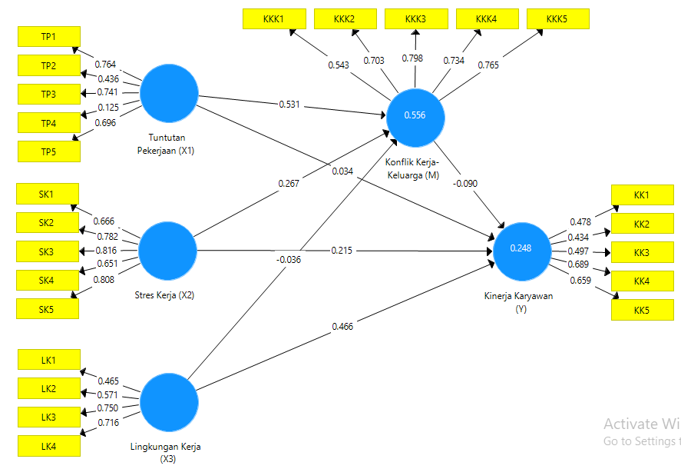
Figure 1. Empirical Results Model

5. Discussion (Trebuchet-12)
Discussion is a crucial part of a scientific article where an in-depth interpretation of the results or findings of a study. The discussion should involve a dynamic process and comparison with some relevant previous studies based on specific scholarship. Discuss each finding carefully to produce representative conclusions and following the objectives of the study. This part should explore the significance of the results of the work, not repeat them. A combined Results and Discussion section is often appropriate. Avoid extensive citations and discussion of published literature. (Calisto MT-11)

6. Conclusion (Trebuchet-12)
The conclusion summarizes the results of the discussion of the results and findings of the study and managerial/policy implications. This section is the main idea of the scientific article (main idea) that is in line with the purposes of the article. Suggest the conclusion present in 3-4 paragraphs of medium size with the last paragraph is managerial implications. (Calisto MT-11)

Recommendation (If any) (Trebuchet-12)
Give advice or recommendations to parties who are relevant and related to this study. Suggestions should be specific, informative, and actionable (max 100 words). (Calisto MT-11)

Limitations and avenue for future research (Trebuchet-12)
Explain in one paragraph (max 70 words) the limitations of the article that we compiled are related to the purpose/problem, the data, and the method or design of the analysis. This article should also provide input for an avenue for future research. (Calisto MT-11)

Funding
Please supply all details required by any funding and grant-awarding bodies as Funding in a separate paragraph as follows:
- For single agency grants:
  - This work was supported by the <Funding Agency> under Grant [number xxxx].
- For multiple agency grants:
  - This work was supported by the <Funding Agency #1> under Grant [number xxxx]; <Funding Agency #2> under Grant [number xxxx]; and <Funding Agency #3> under Grant [number xxxx].

Acknowledgment (Trebuchet-12)
This section is an opportunity for the author(s) to thank those who have contributed to the research and the article, such as providers of research funds (grants), institutions/individuals who provide data or analytical facilities, and experts/reviewers who provide valuable input (max 50 words). (Calisto MT-11)

ORCiD ID: (Author(s), if any) https://orcid.org/signin

References (Trebuchet-12)
Citation in text
Author(s) should use references/papers on this manuscript for the last 10 years sourced from Sinta-accredited national journals and/or international journals indexed by DOAJ, EBSCO, INSPEC, ESCI, GALE, Copernicus, Scopus or WoS. The minimum of references is 25 papers and it is preferable to have a DOI. (Calisto MT-10)

The journal uses the APA (American Psychological Association) 7th Edition Style (author-date method) short reference system for citations in the text with an alphabetical list at the end of the paper. Please ensure that every reference cited in the text is also present in the reference list and vice versa. Please check if all names and surnames of the authors, also the details (title, year, volume, pages, etc.) in the list of references are correct. Unpublished results and personal communications are not recommended in the reference list but may be mentioned in the text. Suppose these references are included in the reference list. In that case, they should follow the standard reference style of the journal and should include a substitution of the publication date with either 'Unpublished results' or 'Personal communication.'

In the text use the following style examples:
- This was explained by Allen (2020)" – single author item
- This was explained in full (Allen, 20206)" – single author item
- This was Concluded in full (Allen & Santosa, 2020) – two authors
- This was discussed in full (Huda et al., 2019)…" – 3 or more authors
- This was stated in full (P. Allen, 2019; S. Allen, 2020)…" where items have similar author names
- This was discussed in full (Allen, 2016a, 2016b)…" where two or more items are published in the same year

Web references
As a minimum, the full URL should be given and the date when the reference was last accessed. If known (DOI, author names, dates, reference to a source publication, etc.), should also give any further information. Web references can be listed separately (e.g., after the reference list) under a different heading if desired or included in the reference list.

Reference style
Text: Citations in the text should follow the referencing style used by the American Psychological Association. You are referred to the Publication Manual of the American Psychological Association, Sixth Edition. List: references should be arranged first alphabetically and then further sorted chronologically if necessary. More than one reference from the same author(s) in the same year must be identified by the letters 'a', 'b', 'c', etc., placed after the year of publication.

Examples:

Reference to a journal publication:
Santosa, P. W. (2020). Determinants of price reversal in high- frequency trading: empirical evidence from Indonesia. Investment Management and Financial Innovations, 17(1), 175-187. doi:10.21511/imfi.17(1).2020.16
Conrad, J., Wahal, S., & Xiang, J. (2015). High-frequency quoting, trading, and the efficiency of prices. Journal of Financial Economics, 116(2), 271-291. https://doi. org/10.1016/j.jfineco.2015.02.008
Reference to a journal publication with an article number:
Van der Geer, J., Hanraads, J. A. J., & Lupton, R. A. (2018). The art of writing a scientific article. Heliyon, 19, e00205. doi:10.1016/j.heliyon.2018.e00205.
Reference to a book:
Montgomery, D. C. (2012). Introduction to statistical quality control (7th ed.). London: Wiley.
Reference to a book chapter:
Slack, B. (2007). The terminalisation of seaports. In J. Wang, D. Olivier, T. Notteboom, & B. Slack (Eds.), Ports, cities, and global supply chains (pp. 41–50). Ashgate.
Reference to a website:
Cancer Research UK. Cancer statistics reports for the UK. (2003). http://www.cancerresearchuk.org/aboutcancer/statistics/cancerstatsreport/ Accessed 13 March 2003.
Conference proceedings
Saraiji, R., Harb, A., & Hamdan, M. O. (2011). Performance of LED street lights in hot environments. In K. Domke & C. A. Brebbia (Eds.), Light in engineering, architecture and environment (pp. 147–158). WIT Press. https://doi.org/10.2495/LIGHT110131
Brown, S., & Caste, V. (2004, May). Integrated obstacle detection framework. Paper presented at the IEEE Intelligent Vehicles Symposium, Detroit, MI.

Thesis or dissertation
Suwetwattanakul, C. (2010). Developing a knowledge sharing model for the implementation of the learning organization in Thailand (Unpublished doctoral dissertation/Thesis). Victoria University, Melbourne, Australia.
Internet documents
Bown, J. (2019, December 17). How charity apps may be making us more generous. BBC News. https://www.bbc.com/news/business-50572939
Dataset:
[dataset] Oguro, M., Imahiro, S., Saito, S., Nakashizuka, T. (2015). Mortality data for Japanese oak wilt disease and surrounding forest compositions. Mendeley Data, v1. http://sci-hub.tw/10.17632/xwj98nb39r.1.

Subdivision - numbered sections
Divide your article into clearly defined and numbered sections. Subsections should be numbered 1.1 (then 1.1.1, 1.1.2, ...), 1.2, etc. (the abstract is not included in section numbering). Use this numbering also for internal cross-referencing: do not just refer to 'the text'. Any subsection may be given a brief heading. Each heading should appear on its separate line.

Appendices
If there is more than one appendix, they should be identified as A, B, etc. Formulae and equations in appendices should be given separate numbering: Eq. (A.1), Eq. (A.2), etc.; in a subsequent appendix, Eq. (B.1) and so on. Similarly, for tables and figures: Table A.1; Fig. A.1, etc.

